

**­­**

**Processor Technologies**

Kevin C. Bigay

ICST240

15 November 2018

Table of Contents

Intel® Core™ Processors

Intel® Core™ i9-9900K @ 3.60GHz 1

Intel® Core™ i5-9600K @ 3.70GHz 1

AMD Ryzen Processors

Ryzen Threadripper 2990WX 3

Ryzen 5 2600X 3

Graphical Processing Units

Nvidia GeForce RTX 2080 Ti 5

Radeon RX Vega 64 5

**Intel® Core™ Processors**

Based on the processors’ specifications, Intel® Core™ i9-9900K and Intel® Core™ i5-9600K are on equal footing based on TDP and yearly running cost. Though Intel® Core™ i9-9900K processors has much physical cores, higher single thread rating, turbo speed and number of samples, Intel® Core™ i5-9600K is 200MHz faster clock speed than Intel® Core™ i9-9900K. Even with the faster clock speed, Intel® Core™ i9-9900K still dominates Intel® Core™ i5-9600K. Based on cpubenchmark.net/, benchmarking this two processors’ performance and estimated energy usage cost, CPU mark and CPU Single Thread Rating of Intel® Core™ i9-9900K proves that it is a more powerful processor than Intel® Core™ i5-9600K although it is much cheaper and has higher marketability than Intel® Core™ i9-9900K. Therefore, choosing between this two processors must depend on how you can maximize its capabilities as a processor for your computer.

**Intel® Core™ i9-9900K @ 3.60GHz Intel® Core™ i5-9600K @ 3.70GHz**

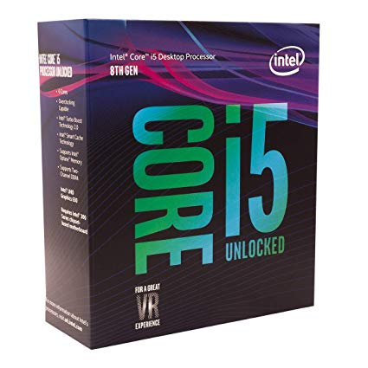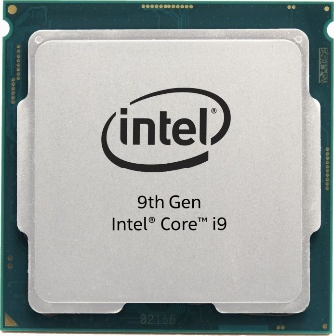

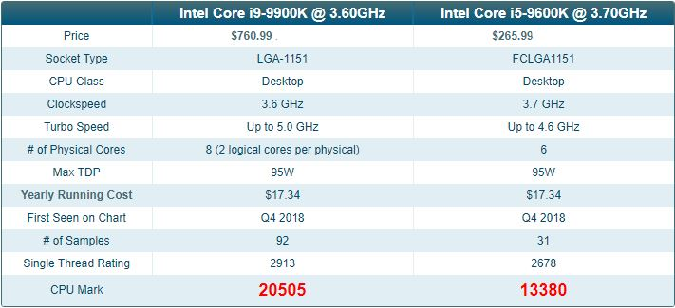**Processor Specifications**

**Benchmarking Results**

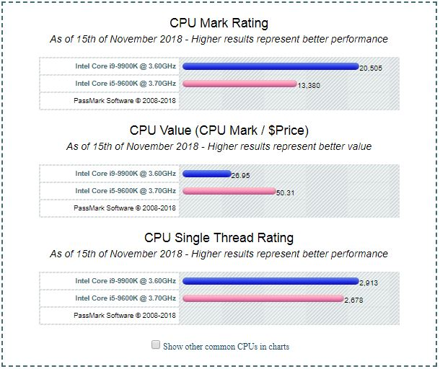

**AMD Ryzen Processors**

AMD Ryzen Threadripper 2990WX processor has a slower clock speed than AMD Ryzen 5 2600X. Other than that, AMD Ryzen Threadripper 2990WX has greater number of physical cores with 2 logical core per physical core. The two processors have the same turbo speed of up to 4.2 GHz. Though AMD Ryzen 5 2600X processor has lower TDP and yearly running cost. The same as the Intel® processors the greater the physical cores and logical cores, the greater the computing power of a processor. The CPU Mark and single thread rating of AMD Ryzen Threadripper 2990WX is far from its AMD Ryzen 5 2600X processor though it is cheaper than the other one.

**AMD Ryzen 5 2600X AMD Ryzen Threadripper 2990WX**

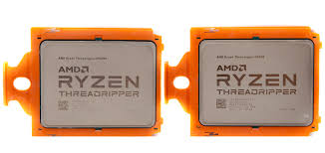

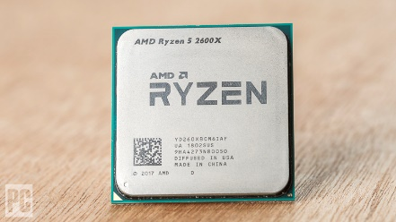

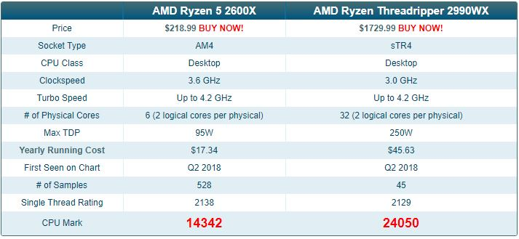**Processor Specification**

**Benchmarking Results:**

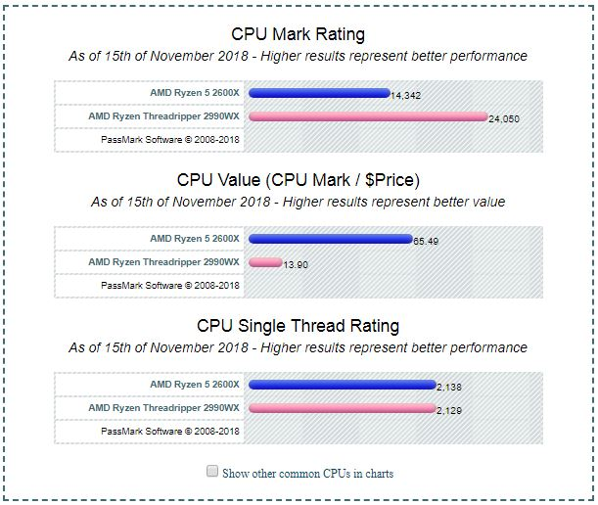

**Graphical Processing Units**

Graphical Processing Units or what we call VideoCards are not only used to render graphical interrupts and I/O also used in data calculation specifically in the field of data mining and machine learning. So with that GPUs capabilities are now utilized and upgraded. Nvidia GeForce RTX 2080 Ti has a faster core clock, maximum speed supported and a lower TDP than Radeon RX Vega 64. Performance based bench mark states that Nvidia GeForce RTX 2080 Ti has a G3D mark than Radeon RX Vega 64. Proving that Nvidia GeForce RTX 2080 Ti is a much powerful GPU than Radeon RX Vega 64.

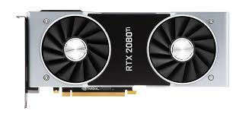**Nvidia GeForce RTX 2080 Ti Radeon RX Vega 64**

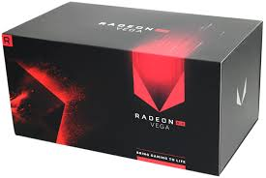

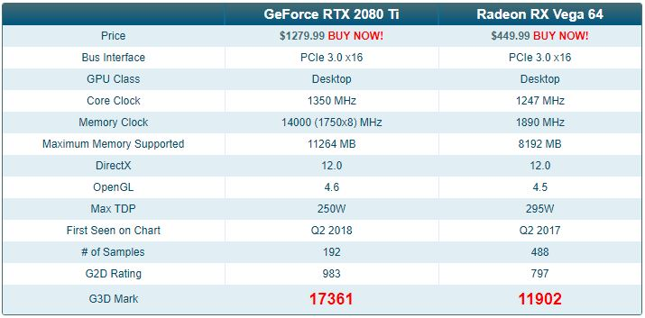**GPU Specification**

**Benchmarking Result**

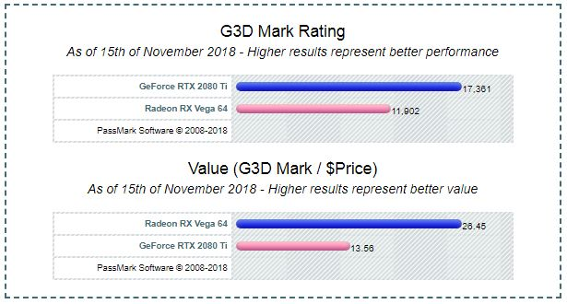

**References:**

**Intel® Core™ Processors Benchmarking Result:**

[**https://www.cpubenchmark.net/compare/Intel-i9-9900K-vs-Intel-i5-9600K/3334vs3337**](https://www.cpubenchmark.net/compare/Intel-i9-9900K-vs-Intel-i5-9600K/3334vs3337)

**AMD Ryzen Benchmarking Result;**

[**https://www.cpubenchmark.net/compare/AMD-Ryzen-5-2600X-vs-AMD-Ryzen-Threadripper-2990WX/3235vs3309**](https://www.cpubenchmark.net/compare/AMD-Ryzen-5-2600X-vs-AMD-Ryzen-Threadripper-2990WX/3235vs3309)

**GPU Benchmarking Result:**

[**https://www.videocardbenchmark.net/compare/GeForce-RTX-2080-Ti-vs-Radeon-RX-Vega-64/3991vs3808**](https://www.videocardbenchmark.net/compare/GeForce-RTX-2080-Ti-vs-Radeon-RX-Vega-64/3991vs3808)